**ASSIGNEMENT 13.2**

PROBLEM STATEMENT

(i) Write a Scala application to find the (Fibonacci series) nth digit in the sequence using standard for loop.

Solution:

Executing scala application for Fibonacci series

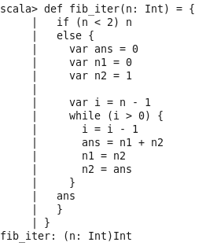

Output:



(ii) Write a Scala application to find the (Fibonacci series) nth digit in the sequence using standard recursion

Execute the Scala Program using recursion

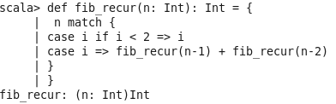

Output:

